IsProgram Log

This is a sample error log used to track errors, problems, or inconsistencies that occur in your programs when testing is taking place. The log can have as many entries as you need. When creating a log entry, you should fill in all of the details below. Do your best to explain the entry, and where necessary you can include evidence (a screenshot maybe, but don’t include an image that takes up the whole page!).

There are five log levels that we are going to use; debug, info, warning, error, critical.

Debug – This is used for tracking informational events when testing a program.

Info – Things are working as expected. This entry is used to track information or updates that need to be made to the code.

Warning – Something unexpected has happened, creating an inconsistency in the program. The program still executes.

Error – A more serious problem which may stop a certain section of the program from running.

Critical – A serious error which may stop the whole program from functioning.

Student Name: John Benedict Ocampo Divinagracia

Module: Fundamentals of Object Oriented Programming

Assignment: Temperature Conversion assignment

**Log Entry 01**

Date & Time: 23/10/2021 4:20 pm

Operating System: Windows 10 Enterprise Edition

Log Level: Critical

Logger: John Benedict

Information: Conflicting variable name. Integers variable name was set up to tempCelsius but the variable setup in system.out.print command is tempCelsius. The C must be uppercase otherwise it wouldn’t be taken as the same thing.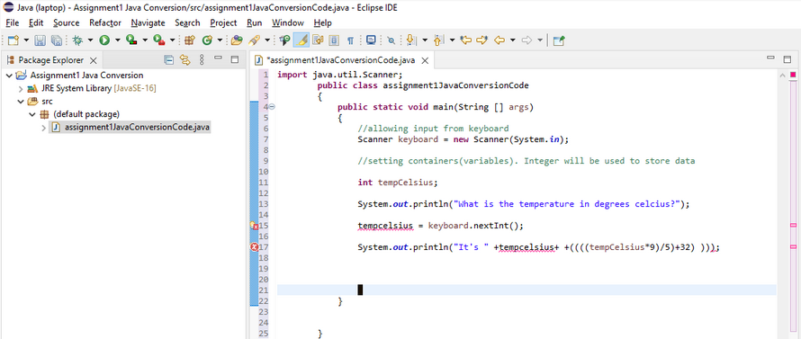

**Log Entry 02**

Date & Time: 23/10/2021 4:39 pm

Operating System: Windows 10 Enterprise Edition

Log Level: Critical

Logger: John Benedict

Information: syntax error. a bracket must be removed. 

**Log Entry 03**

Date & Time: 23/10/2021 5:17 pm

Operating System: Windows 10 Enterprise Edition

Log Level: Critical

Logger: John Benedict

Information: If I don’t put + before values they will merge as one as shown by the result in console

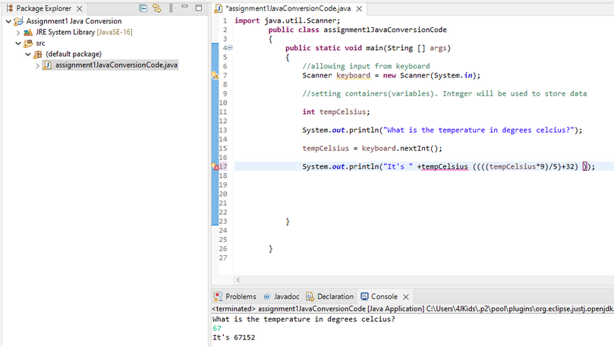

**LLog Entry 04**

Date & Time: 23/10/2021 7:18 pm

Operating System: Windows 10 Enterprise Edition

Log Level: Critical

Logger: John Benedict

Information: The error is because I opened a new java project with a module. There probably is no option in the module to import java.util.scanner. The original methods/functions/imports of the downloaded java file was overwritten by the opened module. To prevent this, don’t import a module when opening a new project. **Note that names of java projects are different because the codes were saved through onenote but the projects are saved in 2 separate computers: laptop and school computer.**

angnm 
Eile Edit Réctor 
cnt 
Nnig'te 
EmJ«t 
assignment •assignment 'JavaCONersionCode.java X 
I match the O d e • 
Add package declaration 'assignment1JavaCometsionCOde' 
to def"lt i mpotjava.util.Scmne, 
@ java 
from ro or click tortocu 
at least you dent have to about bacterial Infection. • 
that's 
else if (tempCeIsius ) 
•Wow that ' s hot I—ao!"); 
else if (tempCeIsius IS) 
Syste..out.printIn('CaII saweety that' s 
Syste..out.printIn(Nhat a beautiful day! This is the best day of lifes 
"in C on sole X 
(l) [Java Application] C; 
myself 
thread 
" Lang _ 
( 24) 

**Log Entry 05**

Date & Time: 24/10/2021 2:27 pm

Operating System: Windows 10 Enterprise Edition

Log Level: Critical

Logger: John Benedict

Information: The issue seems to persist so it seems as though the root of the issue is the package. This means that the original findings were incorrect. A new class was created but in the same project. This time the package input was deleted to put it back on default. Issues ceased to exist. Package Explorer X 
assignmentl 
JRE System Library [JavaSE-16] 
v (default package) 
u:] assignment I java 
assignment I JavaConversionCode 
JRESystem Library [JavaSE-16] 
assignment I JavaConversionCode2 
JRE System Library [JavaSE-16] 
v (default package) 
assignment I JavaConversionCode2java 
assignmentl JavaConversionCode2 
assignment I JavaConversionCode2java 
projects 
import 
u) assignmentIJavaC.. 
java . util. Scanner; 
u) assignmentIJavaC... 
•assignmentIJava.. 
0) •assignmentl.java 
assignmentIJavaC... 
X 
assignmentIJava( 
public class assignmentIJavaConversionCode2 
public static void main (String args) 
/ 'allowing input from keyboard 
Scanner = new Scanner(System. in); 
/ 'setting containers (variables). Integer will be used to store data 
int tempCeIsius; 
is 
the temperature in degrees celcius?"); 
tempCeIsius = keyboard. nextlnt(); 
tempCeIsius+ "oc or " 
if (tempCeIsius > 
System. out. println ("Hot 
else if (tempCeIsius > 4ø ) 
System. out. println ("Wow 
else if (tempCeIsius < 15) 
damn, that's hot! Well, 
that's hot Imao!"); 
at least you dont have to payry about bacterial infection. " 
mcmma saweety cuz DAMN, that's icy!"); 
else 
a beautiful day! This is the best day of my life, 
I'm killing myself tcmorrow. 

**Log Entry 07**

Date & Time: 25/10/2021 3:47 pm

Operating System: Windows 10 Enterprise Edition

Log Level: Critical

Logger: John Benedict

Information: Print was supposed to be "that’s too hot..." Instead of "that’s hot". This may have been caused by not using equal signs to include the maximum values of each interval. I added equal signs to include 100, 40, 15 degrees.

eclipse-workspace - assignmentIJavaConversionCode2/src/assignmentIJavaConversionCode2.java - 
Eile Edit Source Refactor Navigate Search project Bun Window 
Help 
Donate 
Eclipse IDE 
u:] assignmentIJavaC.. 
Package Explorer X 
assignmentl 
JRESystem Library [JavaSE-16] 
v (default package) 
u:] assignment I java 
assignment I JavaConversionCode 
JRESystem Library [JavaSE-16] 
assignment I JavaConversionCode2 
JRESystem Library [JavaSE-16] 
(default package) 
assignment I JavaConversionCode2java 
assignmentl JavaConversionCode2 
assignment I JavaConversionCode2java 
projects 
assignmentIJavaC... 
•assignmentIJava.. 
*assignmentl.java 
assignmentIJava... 
X 
assignmentIJa' 
import java. util.Scanner; 
public class assignmentIJavaConversionCode2 
public static void main (String args) 
/ 'allowing input from keyboard 
Scanner = new Scanner(System. in); 
/ 'setting containers (variables). Integer will be used to store data 
int tempCeIsius; 
is 
the temperature in degrees celcius?"); 
tempCeIsius = keyboard. nextlnt(); 
if (tempCeIsius > 
tempCeIsius+ 
too hot! Well, 
else if (tempCeIsius > 4ø ) 
that's hot!"); 
else if (tempCeIsius < 15) 
or 
at least you dont have to worry about bacterial infection. 
Elsa and Anna cause that's icy!"); 
else 
a beautiful day! This is the best day of my life! (so far). 
Problems @ Javadoc Declaration Console 
assi nmentIJavaConversionCode2 [Java A 
What is the temperature in degrees celcius? 
It's løøoc or 2120F! 
Wow that's hot! 
x 
lication] •.divi 
racia21 
Iu ins\or .ecli 
endk.hots 
:re.full.win32x86 64 170.0...,20211012 

**Log Entry 08**

Date & Time: 25/10/2021 7:23 pm

Operating System: Windows 10 Enterprise Edition

Log Level: Critical

Logger: John Benedict

Information: Equal sign goes before less than and more than symbols

File 
clipse-workspace - assignmentIJavaConversionCode2/src/assignmentIJavaConversionCode2.java - 
Edit Source Refactor Navigate Search project Bun Window 
Help 
Donate 
Eclipse IDE 
u:] assignmentIJavaC... 
Package Explorer X 
assignmentl 
JRESystem Library [JavaSE-16] 
v (default package) 
u:] assignment I java 
assignment I JavaConversionCode 
JRESystem Library [JavaSE-16] 
assignment I JavaConversionCode2 
JRESystem Library [JavaSE-16] 
(default package) 
assignment I JavaConversionCode2java 
assignmentl JavaConversionCode2 
assignment I JavaConversionCode2java 
projects 
assignmentIJavaC... 
•assignmentIJava.. 
*assignmentl.java 
assignmentIJava... 
X 
assign 
import java. util.Scanner; 
ublic class assignmentIJavaConversionCode2 
public static void main (String args) 
/ 'allowing input from keyboard 
Scanner keyboard = new Scanner(System. in); 
/ 'setting containers (variables). Integer will be used to store data 
int tempCeIsius; 
is 
the temperature in degrees celcius?"); 
tempCeIsius = keyboard. nextlnt(); 
tempCeIsius+ "oc or " 
if 
too hot! 
well, 
else if ) 
that's hot!")• 
else if 
at least you dont have to payry about bacterial infection. 
Elsa and Anna cause that's icy!"); 
else 
a beautiful day! This is the best day of my life! (so far). 
Problems @ Javadoc Declaration Console 
assi nmentIJavaConversionCode2 [Java A 
What is the temperature in degrees celcius? 
It's løøoc or 2120F! 
Wow that's hot! 
x 
lication] •.divi 
racia21 
Iu ins\or .ecli 
endk.hots 
:re.full.win32x86 64 170.0...,: 

**Log Entry 09**

Date & Time: 04/11/2021 3: 18 pm

Operating System: Windows 10 Enterprise Edition

Log Level: Critical

Logger: John Benedict

Information: Template given by the instructor was followed but errors exist within the public static void info class. It was determined that the error is due to conflicting variable names and/or data type.

Machine generated alternative text:
Package Explorer X 
assignmentl 
assignment I JavaConversionCode 
assignment I JavaConversionCode2 
projects 
Donate 
import 
O] assignmentIJavaC... 
java . util. Scanner; 
assignmentIJavaC... 
assignmentIJavaC... 
assignmentl.java 
assignmentIJava... 
X 
assignmentIJava• 
public class assignmentIJavaConversionCode2 
public static void main (String args) 
/ 'allowing input from keyboard 
Scanner = new Scanner(System. in); 
/ 'setting containers (variables). Integer will be used to store data 
int tempCeIsius; 
is 
the temperature in degrees celcius?"); 
tempCeIsius = keyboard. nextlnt(); 
tempCeIsius+ "oc or " 
if (tempCeIsius 
too hot! 
well, 
else if (tempCeIsius 
that's hot!")• 
else if (tempCeIsius 15) 
else 
public static void info d] 
at least you dont have to payry about bacterial infection. " 
Elsa and Anna cause that's icy!"); 
a beautiful day! This is the 
String name = showInputDiaIog(nuII, "Hi! What 
String age Type = showInputDiaIog(nuII, "Okay 
Agg. = a String value 
best day of my life! (so far)."); 
is your name? 
"*name 
what age are you?"); 
to an integer 

**Log Entry 10**

Date & Time: 04/11/2021 5:28 pm

Operating System: Windows 10 Enterprise Edition

Log Level: Critical

Logger: John Benedict

Information: The console “prints” out the information so the cause of the issue may have been from importing java utilities that allow keyboard (printing) function. In the “TestProgram.java” document given by the instructor, “javax.swing'' was imported instead of “java.util.scanner.” Therefore “java.util.scanner” shall be replaced with “javax.swing”.

Machine generated alternative text:
Package Explorer X 
assignment I 
assignment I JavaConversionCode 
assignmentIJavaConversionCode2 
p rojects 
Donate 
import 
Problems 
assignmentIJavaC... 
java . util. Scanner; 
assignmentIJavaC... 
assignmentIJavaC... 
assignm entl .java 
assignmentIJavaC... 
x 
assignmentIJavaC... 
public class assignmentIJavaConversionCode2 
public static void main (String args) 
/ 'allowing input from keyboard 
r = new Scanner (System. in); 
Scanne 
/ 'setting containers (variables). Integer will be used to store data 
int tempCeIsius; 
is 
the temperature in degrees celcius?"); 
tempCeIsius = keyboard. nextlnt(); 
tempCeIsius+ "oc or " 
if (tempCeIsius 
too hot! 
well, 
else if (tempCeIsius 
that's hot!")• 
else if (tempCeIsius 15) 
else 
public static void info() 
at least you dont have to payry about bacterial infection. " 
Elsa and Anna cause that's icy!"); 
a beautiful day! This is the best day of my life! (so far). 
String tempCeIsius = showInputDiaIog(nuII, "What is the temperature in degrees celcius?"); 
tempCeIsius = a String value to an integer 
@ Javadoc Declaration Console 
x 
lication] 
assi nmentIJavaConverslonCode2 [Java A 
What is the temperature in degrees celcius? 
tvs 340C or 930F! 
Idivina racia21\. 
far) • 
Iu ins\or 
.ecll 
e:ustlo endk.hots ot:re.fuII.win32.x86 64 17.0.O.v20211012-10 
What a beautiful day! This is the best day of my life! (so 

**Log Entry 11**

Date & Time: 04/11/2021 11:33 pm

Operating System: Windows 10 Enterprise Edition

Log Level: Critical

Logger: John Benedict

Information: Error said to occur in line 7 where “scanner.keyboard” is no longer supported as it is not the imported utility/package. Therefore scanners were taken out, as “javax.swing” already allows keyboard input.

Machine generated alternative text:
import javax. swing. * • 
public class assignmentIJavaConversionCode2 
public static void main (String args) 
/ 'allowing input from keyboard 
keyboard = new in); 
/ 'setting containers (variables). Integer will be used to store data 
int tempCeIsius; 
is 
the temperature in degrees celcius?"); 
tempCeIsius = keyboard. nextlnt(); 
tempCeIsius+ "oc or " 
if (tempCeIsius 
too hot! 
well, 
else if (tempCeIsius 
that's hot!")• 
else if (tempCeIsius 15) 
else 
public static void info() 
String tempCeIsiusType 
at least you dont have to payry about bacterial infection. " 
Elsa and Anna cause that's icy!"); 
a beautiful day! This is the best day of my life! (so far). 
JOptionPane.showInputDiaLog(nuII, "What is the temperature in degrees celcius?"); 
= a String value to an integer 

**Log Entry 12**

Date & Time: 06/11/2021 2:47 pm

Operating System: Windows 10 Enterprise Edition

Log Level: Critical

Logger: John Benedict

Information: Data for variables were originally brought forth by the java.util.scanner but since it has been taken out system.out.print shall be replaced with JOptionPane.showMessageDialog(null,….).

Machine generated alternative text:
import javax. swing. * • 
public class assignmentIJavaConversionCode2 
public static void main (String args) 
/ 'setting containers (variables). 
int tempCeIsius; 
Integer will be used to store data 
is the temperature in degrees celcius?"); 
ey>gbcd. nextl ( ) ; 
tempCeIsiu s 
tempCeIsius+ "oc or " 
if (tempCeIsius 
too hot! 
well, 
else if (tempCeIsius 
that's hot!")• 
else if (tempCeIsius 15) 
else 
public static void info() 
String tempCeIsiusType 
at least you dont have to payry about bacterial infection. 
Elsa and Anna cause that's icy!"); 
a beautiful day! This is the best day of my life! (so far). 
JOptionPane.showInputDiaLog(nuII, "What is the temperature in degrees celcius?"); 
= a String value to an integer 

**Log Entry 13**

Date & Time: 06/11/2021 5:11 pm

Operating System: Windows 10 Enterprise Edition

Log Level: Critical

Logger: John Benedict

info: Errors occurred in lines where the variable “tempCelsius” are located. It was hypothesized that the issue may have been the cause of the variables being in different classes. Therefore, a global integer variable shall be created within the main class. This can be done by making the main method be a normal method and name it “output” since it gives out output using the “javax.swing” utility package, then make a new main class.

Machine generated alternative text:
import javax. swing. * • 
public class assignmentIJavaConversionCode2 
Integer will be used to store data 
"oc or " 
3 38 
public 
public 
static void main (String args) 
/ 'setting containers (variables). 
int tempCeIsius; 
if 
JOptionPane.shoWdessageDiaLog(nuII, "That's too hot! Well, 
else if 4ø ) 
JOptionPane.shoWdessageDiaLog(nuII, "Wow that's hot!"); 
else if 15) 
else 
static void info ( ) 
at least you dont have to payry about bacterial infection. 
JOptionPane.shoWdessageDiaLog(nuII, "Call Elsa and Anna cause that's icy!"); 
JOptionPane.shoWdessageDiaLog(nuII, "What a beautiful day! This is the best day of my life! (so far). 
String tempCeIsiusType = JOptionPane.showInputDiaLog(nuII, 
"What is the temperature in degrees celcius?"); 
= a String value to an integer 